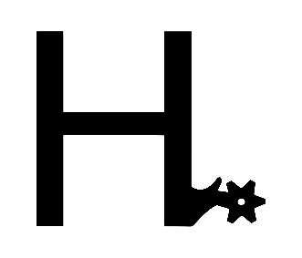

Whether you’re a first-time buyer or a seasoned veteran, it’s important to do your due diligence as a buyer. Below are some things to do and remember when purchasing any horse!
-Review all information given, including pictures and videos
-Contact the seller with any questions you might have.
-Schedule an appointment to see the horse if you can do so.
-Schedule a PPE within a reasonable time frame if you would like one.

Once you’ve made the decision to purchase, contact us to get everything set up!
- Call or text 817-366-6123
- Email us at hspurhorses@gmail.com
If you are paying with a wire transfer, we will send you wiring instructions via text or email to send the agreed-upon amount to.
If buying from out of state or sight unseen, we will need your email address to send you an e-sign request for the Bill of Sale.
The Bill of Sale and wire must both be sent to us within 24 hours of receiving the instructions and e-sign request. Failure to do so will result in the horse being re-listed or allowing the next person in line the opportunity to purchase them.
The next step is setting up transport (if needed)! You can find a list of reputable haulers on our website if you do not already have one you would like to use. If the horse will be going out of state for delivery, a Health Certificate will also be needed and is the buyer's responsibility. We are happy to haul the horse to our vet to get one. The cost is $50. If the horse will be staying longer than 72 hours after the time of purchase with H spur Horses, a Boarding Contract will also need to be signed and $20 per day the horse is will remain with us will also need to be paid with the wire transfer or can be paid via Venmo. The Boarding Contract can also be sent electronically to be signed.
Once you have received your horse, be sure to send us updates! We love seeing our horses in their new homes and going on new adventures. The horses we sell become our family members and by buying a horse from us, you become a part of our family too!

